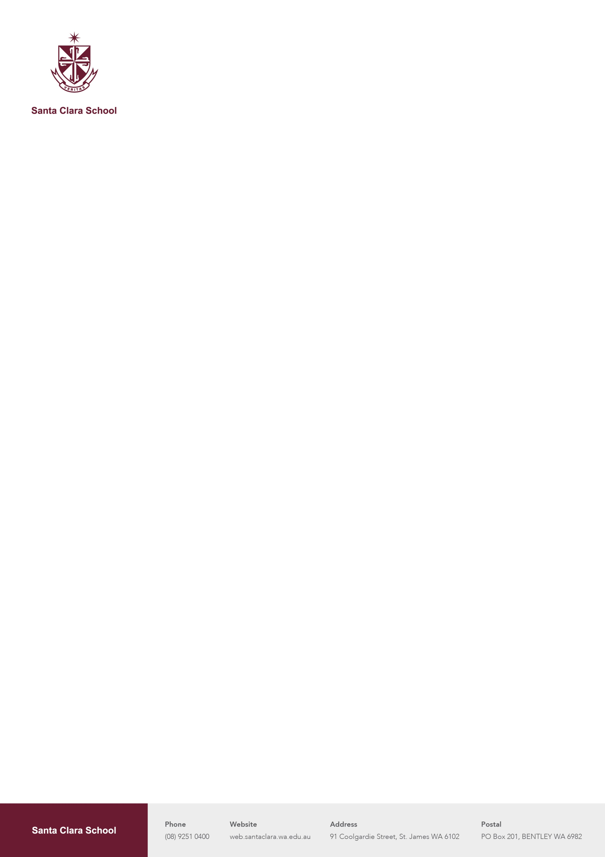

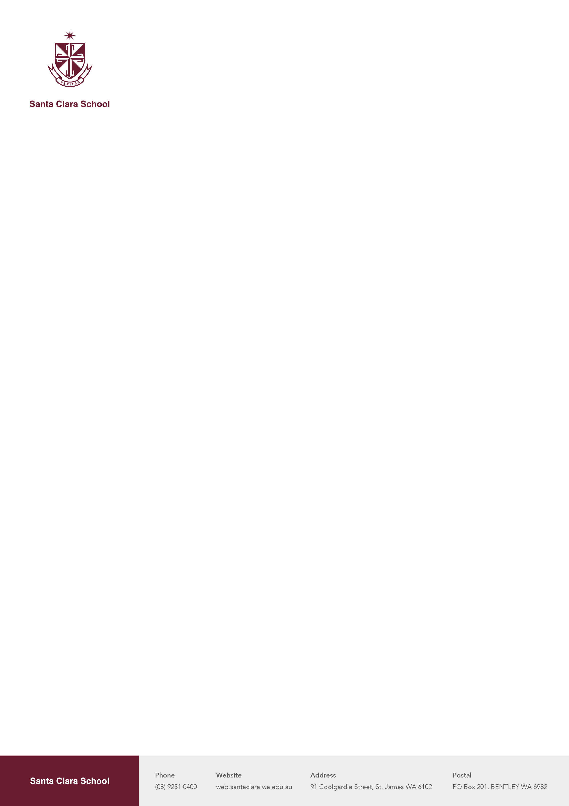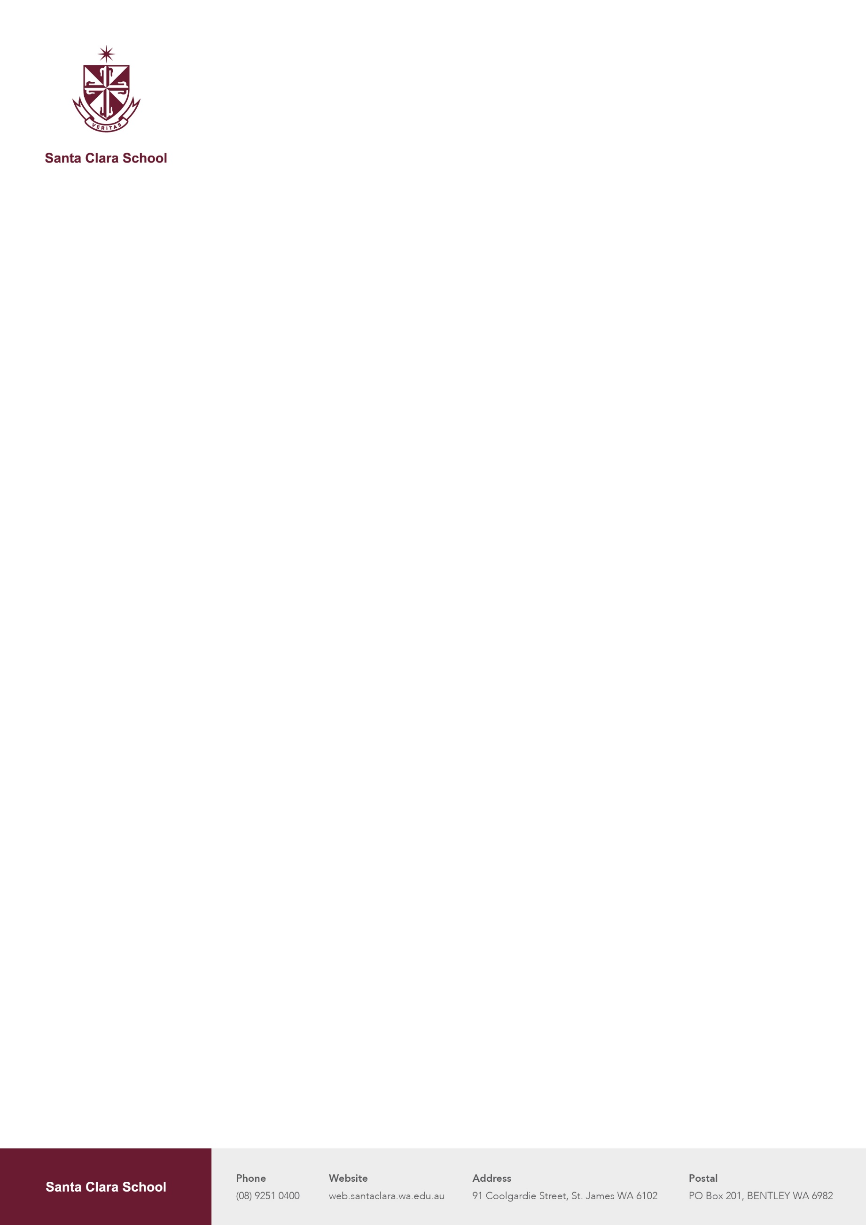

**Educator – Out of School Hours Care**

$29.29 - $35.68 per hour - Casual

**About Us**

Santa Clara Out of School Hours Care is a branch of the innovative and creative educational team at Santa Clara School.  We care for the children in the community during before and after school care as well as over the Vacation Care periods.  We offer:

* Paid training in a range of areas such as first aid, behaviour management, quality improvement plans, anaphylaxis as well as others, ensuring your success
* Structured induction, mentoring, ongoing professional and career development, and a supportive leadership team

**About The Role**  
  
We are looking for a passionate and energetic Educator to join our dedicated and supportive team, in St James on a casual basis. Our hours of operation are 7am to 9am and 2pm to 6pm, Monday to Friday. We also run a vacation care program that operates all day from 7:30am to 6pm in the school holidays. To succeed in this position you will need to:

* Use your skills and interest to engage primary-aged children;
* Team work to deliver creative games and activities;
* Incorporate cooking and meal preparation into experiences for children;
* Active supervision and consistent head count to manage safety.
* Play based learning, incorporating children's ideas and interests into planned experiences and routines;
* Welcoming children to the service each day
* Ensure children are always supervised during service

**About You**  
  
Play is vital to children's well-being and sense of belonging and forms the basis of who they become in the future. Our ideal team member strongly reflects these qualities.  
  
We prefer all educators to either be studying towards or have completed a relevant qualification. This can include Teaching, Childcare, Psychology, Nursing, Youth Work, Social Work and more. In addition to this we also need:

* A current Employee ‘Working With Children's Check’
* A criminal record check valid in the last 3 months
* Valid Working Rights to work in Australia

We are more than happy with students who are working toward their qualifications.

**Applications**

Please send your applications through to osc@santaclara.wa.edu.au.